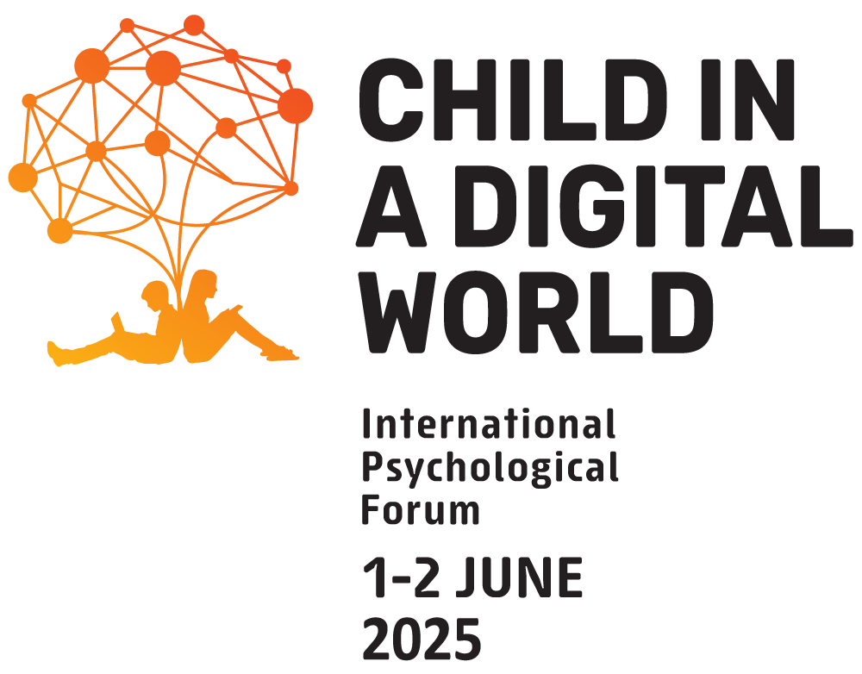

Dear colleagues!

The V International Psychological Forum "Child in a Digital World" is dedicated to the issues of sustainable development of children and adolescents in the context of the transformation of childhood caused by the digitalization of modern society.
The Forum is initiated by the Federal Scientific Center for Psychological and Interdisciplinary Research in cooperation with the Faculty of Psychology, Lomonosov Moscow State University and the Russian Psychological Society, since 2021. The Forum is held with the support of Ministry of Science and Higher Education of the Russian Federation, Federation Council Committee on Science, Education and Culture, and the Commission of the Russian Federation for UNESCO.
The Forum is held online. Every year more than 11,000 specialists from 75 countries take part in the Forum.
All the presentations of plenary speakers are simultaneously translated into three languages: Russian, English and Spanish. Participation in the Forum is free. All registered participants will receive the certificate.

Participation formats
Scientists, teachers and practitioners are invited to participate and present the results of empirical and theoretical research in all areas of childhood studies. Topics to be discussed include digital technologies and artificial intelligence in education, mental and physical health of children, interdisciplinary and cross-cultural studies of childhood, prevention of digital risks, psychological rehabilitation of children and adolescents and much more.
There are three formats of participation at the Forum:
1. Keynote speaker. Participation as a speaker of the plenary section online.
2. Speaker. Includes the presentation of a video report up to 7 minutes in any of the official languages of the Forum (Russian, English, Spanish) accompanied by a PowerPoint presentation in English. To participate in the Forum as a speaker, you have to submit abstracts reflecting the results of your research work.
3. Participant. Participation in the Forum without a report.

Registration
To participate in the Forum as a speaker, please register following this link https://conference-portal.ru/en/ before April 15, 2025.
To participate in the Forum as a participant, please register following this link https://conference-portal.ru/en/ before May 1, 2025.

For more information about the Forum visit our website https://digitalchildhood.org/

